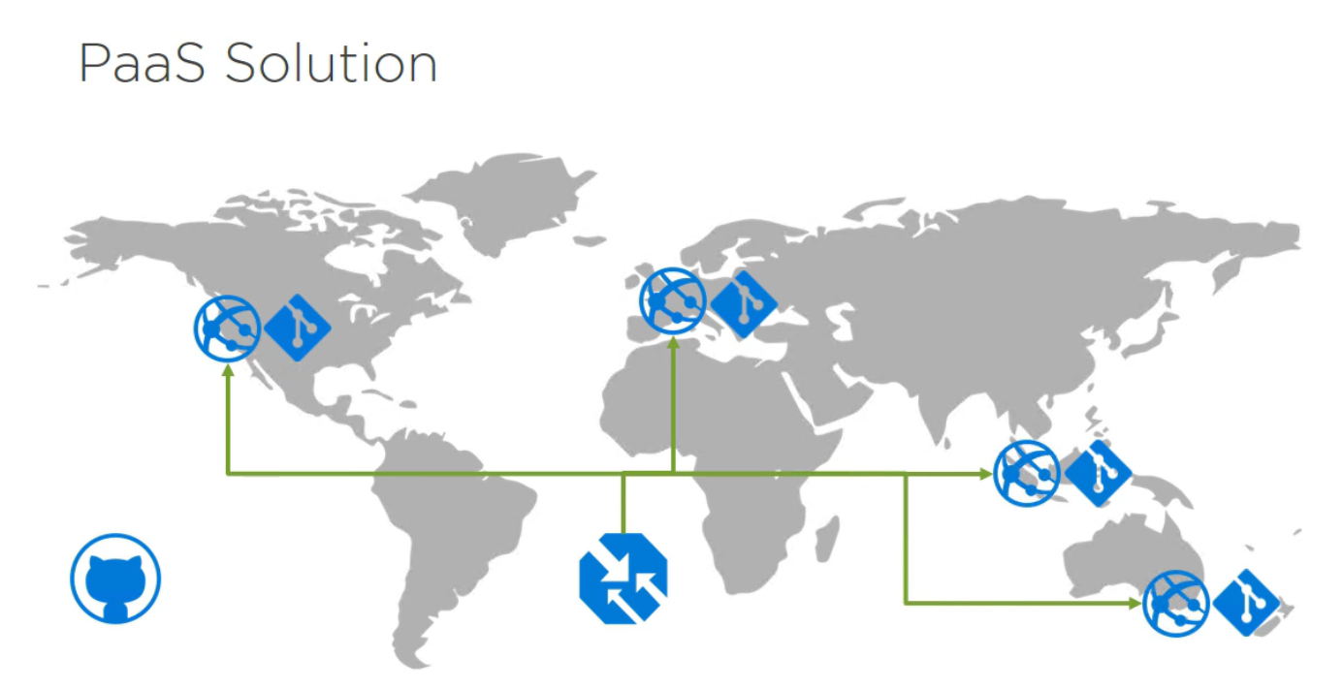

*Traffic manager

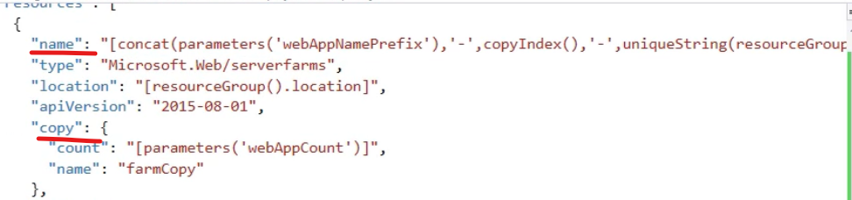

Get a value from an array:

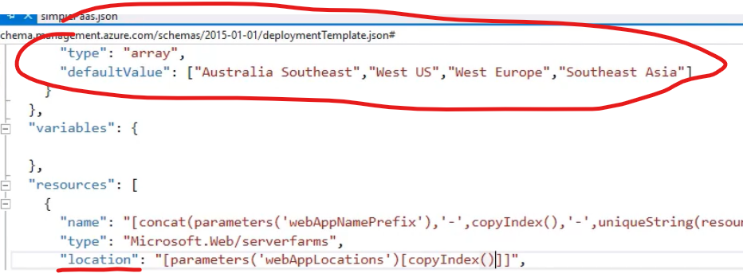

Eg. We have 4 app service plans, and 4 web apps (one for each):  
in the service plan:  
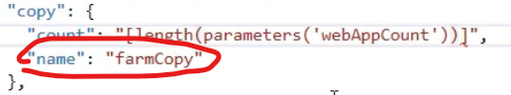

So the child (webapp) can use:

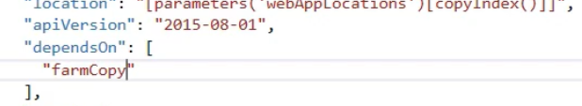

Traffic manager resource:  
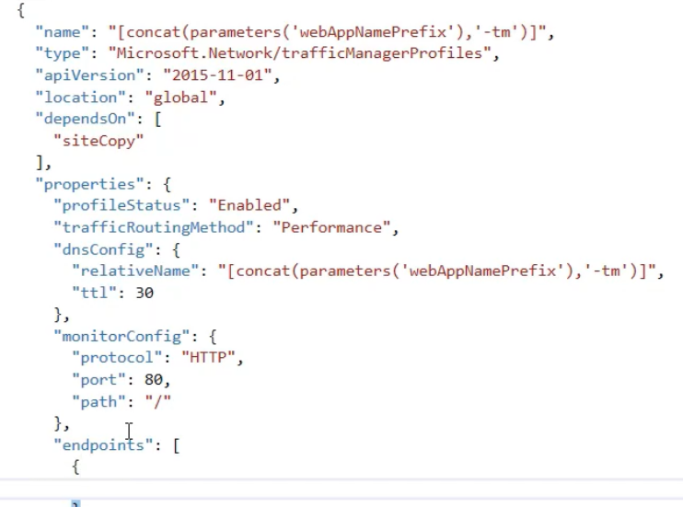

**SubResource:** resource can contain additional resources: eg. Populating Web App resource from Source Control: **dependsOn tag is not necessary here, but won’t hurt**

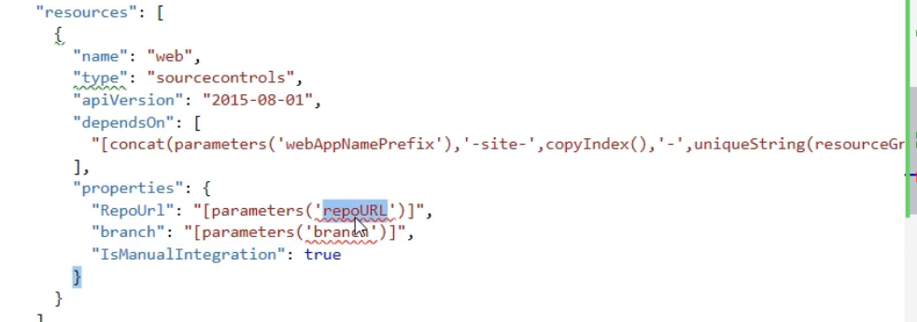

**(this is within a “resources” tag already ^)**